**Assignment 4- Practicing Property & Event Binding and View Encapsulation**

Time to practice the things you just learned! In this assignment, you're going to bind to your own events and properties and also use view encapsulation to style everything just the way it should look like.

The snapshot below explains the example app you're starting with and which tasks should be completed as part of this assignment.

Make sure to also answer why you implemented the solution you chose to use.

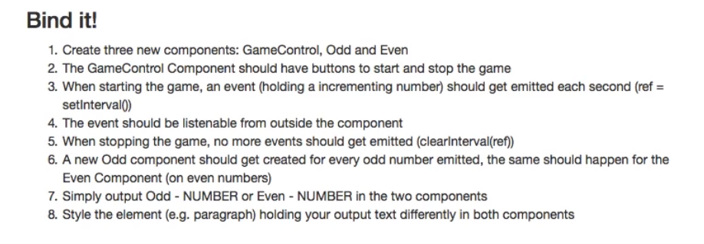

**Questions for this assignment**

**Please complete the tasks outlined in the instructions below. Why did you choose the approach you took? Which problems did you encounter?**

**Download resource files**

* cmp-databinding-assignment-start.zip